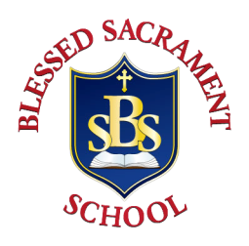
Blessed Sacrament Catholic School
2020 Summer Reading Summary Assignment

Student’s Name

Name of Free Choice Book

Author(s)

Book Summary

Please write a summary of your Free Choice Book. Your summary should include the setting, theme, main characters, problem and solution.

My Favorite Quote or Line Was…

My Favorite Part Was…

Make A Connection

You can choose ONE of the following connections:
  - Text-to-Self: Connect the book to something that has happened to you.
  - Text-to-Text: Connect the book to another book you have read.
  - Text-to-World: Connect the book to something happening in the world.

Book Recommendation
Circle your recommendation for this free choice book….

